## **Drone Script System Documentation**

### **Overview**

This documentation explains the implementation and setup of the drone script system used for enemy drones.The system includes drone behaviors such as attacking, falling back, and patrolling, triggered by interactions with the player

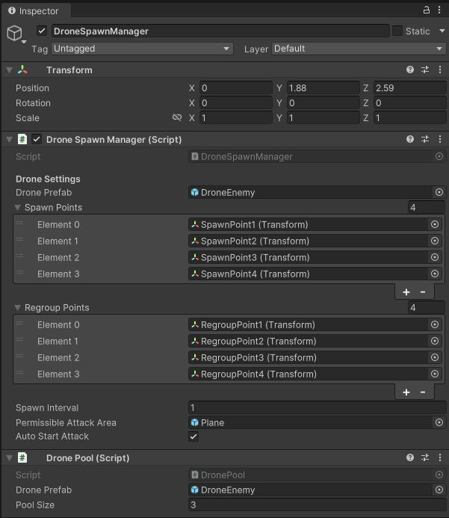

#### **DroneSpawnManager**

The DroneSpawnManager handles the spawning and regrouping of drones in the game.

* **Drone Prefab**: Prefab used for the drone (DroneEnemy).
* **Spawn Points**: List of transforms where drones can spawn.
* **Regroup Points**: List of transforms where drones can regroup after certain behaviors.
* **Spawn Interval**: Time interval between drone spawns.
* **Permissible Attack Area**: The plane that constrains the drone's movement.
* **Auto Start Attack**: Boolean indicating if drones start attacking automatically.

#### **DronePool**

The DronePool script manages a pool of drone instances to optimize performance and reduce instantiation overhead.

* **Drone Prefab**: Prefab used for the drone (DroneEnemy).
* **Pool Size**: Number of drone instances to maintain in the pool.

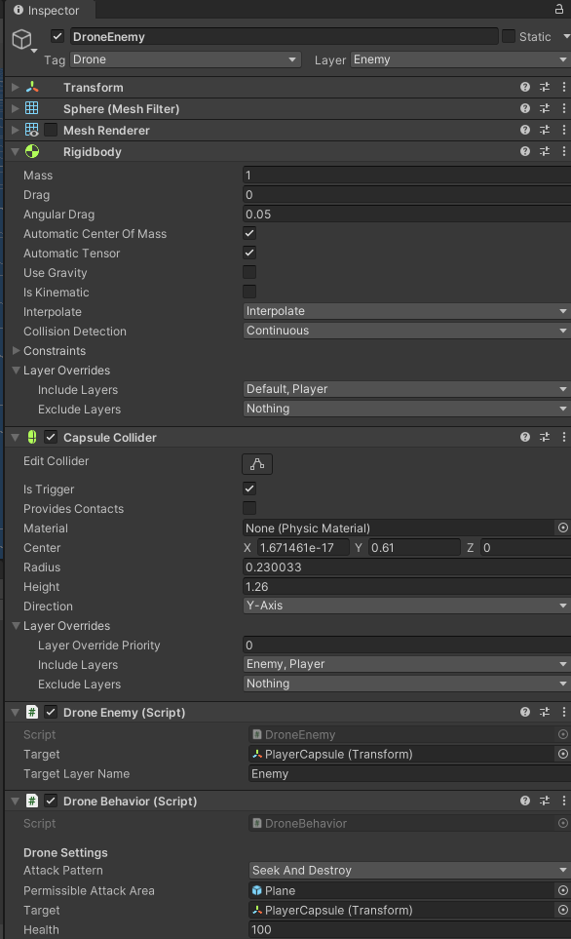

#### **DroneEnemy**

The DroneEnemy script sets up the drone's target and layer settings.

* **Target**: The player's transform (PlayerCapsule).
* **Target Layer Name**: The layer name assigned to the drone (Enemy).

#### **3. DroneBehavior**

The DroneBehavior script manages the drone's behavior, including attack patterns, fallback, and patrolling.

* **Attack Pattern**: Enum indicating the current attack pattern (SeekAndDestroy, HomingCharge, CircularEncirclement).
* **Permissible Attack Area**: The plane that constrains the drone's movement.
* **Target**: The target the drone will attack (typically the player).
* **Health**: Health of the drone.

### **Drone Behavior Script Method Breakdown**

The DroneBehavior script handles the main functionality of the drone. It includes the following key methods:

1. **InitializeTarget**: Finds and sets the target for the drone.
2. **InitializeAttackArea**: Sets the bounds of the permissible attack area.
3. **ExecuteAttackPattern**: Executes the current attack pattern.
4. **SeekAndDestroy**: Moves the drone towards the target in a straight line.
5. **HomingCharge**: Moves the drone towards the target with a homing behavior.
6. **CircularEncirclement**: Moves the drone in a circular path around the target.
7. **MoveToTarget**: Moves the drone to the specified target position with a specified ease and duration.
8. **HandleCollisionWithPlayer**: Handles logic when the drone collides with the player, including applying force, reducing health, and triggering fallback behavior.
9. **FallBack**: Moves the drone back after a collision and starts the defensive state.
10. **StayDefensive**: Keeps the drone in a defensive state for a specified duration.
11. **StartPatrol**: Starts the drone's patrolling behavior after the defensive state.
12. **GetRandomPositionWithinBounds**: Gets a random position within the permissible attack area bounds.
13. **HandleLaserCollision**: Handles logic when the drone collides with a laser.
14. **CheckProximity**: Continuously checks and maintains separation between drones.
15. **ApplySeparation**: Ensures drones maintain a minimum separation distance.
16. **SearchForPlayer**: Searches for the player within a specified radius.

### **Behavior Flow**

1. **Initialization**: The drone initializes its target and permissible attack area on start.
2. **Attack Pattern Execution**: The drone continuously executes its attack pattern until an event (e.g., collision) interrupts it.
3. **Collision Handling**: On colliding with the player, the drone applies force to the player, reduces health, and triggers fallback.
4. **Fallback and Defensive State**: The drone moves back from the collision point and stays in a defensive state for a specified duration.
5. **Patrolling**: After the defensive state, the drone starts patrolling within the permissible attack area.
6. **Resuming Attack**: Once patrolling is complete, the drone resumes its attack pattern.

### **Setup Instructions**

1. **Assign Drone Prefab**: Assign the DroneEnemy prefab to the Drone Prefab field in the DroneSpawnManager.
2. **Configure Spawn and Regroup Points**: Set the spawn and regroup points in the DroneSpawnManager.
3. **Assign Permissible Attack Area**: Assign the plane game object to the Permissible Attack Area field.
4. **Set Target and Layer**: In the DroneEnemy script, set the Target to the player's transform and the Target Layer Name to Enemy.
5. **Configure Drone Behavior**: Set the desired attack pattern and other parameters in the DroneBehavior script.